Project 13：RGB Module

1. Description
The RGB color mode is a color standard in the industry. It obtains various colors by changing the three color channels of red (R), green (G), and blue (B) and integrating them. RGB denotes the three colors of red, green and blue.
The monitors mostly adopt the RGB color standard, and all the colors on the computer screen are composed of the three colors of red, green and blue mixed in different proportions. A group of red, green and blue is the smallest display unit. Any color on the screen can be recorded and expressed by a set of RGB values.
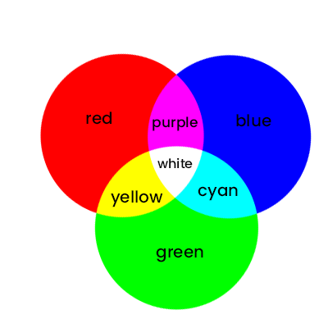
RGB color mixing is like having red, green and blue lamps. When their light is superimposed on each other, the colors are mixed, while the brightness is equal to the sum of the brightness of the three lamps. The more mixed, the higher the brightness, therefore, it is often called seven-color LED.

Color | RGB value（R,G,B） | Color | RGB value（R,G,B）
Black | 255,255,255 | Red | 0,255,255
Green | 255,0,255 | Blue | 255,255,0
Cyan | 255,0,0 | Dark red | 0,255,0
Yellow | 0,0,255 | White | 0,0,0
...... | ....... | ...... | ......

Since our LED lights are common anode, 255 is the lowest value and 0 is the brightest value.
In this project, we are going to make two experiments. One is to make two RGB lights light up three colors of red, green and blue, the other is to make two RGB lights gradually display different colors.

2. Preparation
（1）Insert the micro: bit correctly into the expansion board
（2）Connect the battery holder to the expansion board
（3）Turn on the power switch（Slide the POWER switch to ON end）
（4）Connect the micro：bit and computer via a micro USB cable
（5）Open the Web version of Makecode
If you want to add the Mini car extension library(you can refer to the "1. Development environment configuration "file).

3. Schematic Diagram

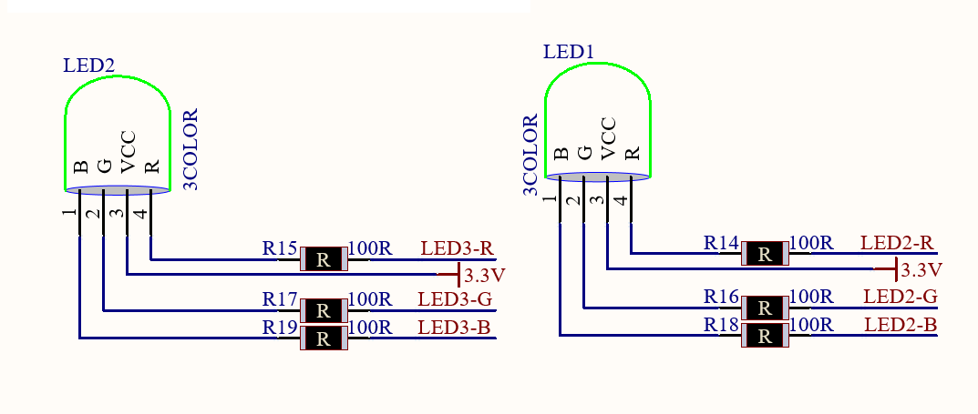
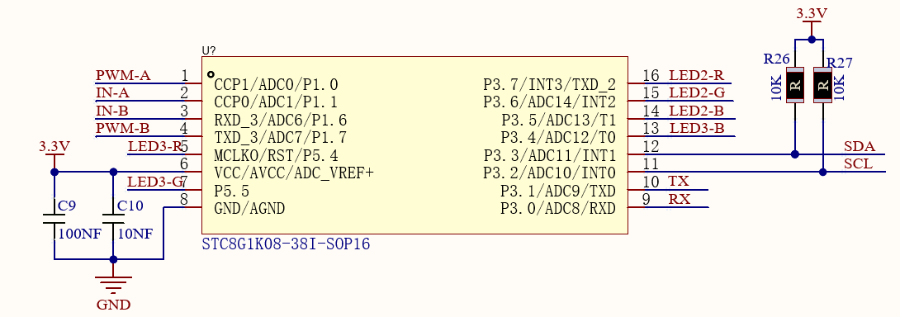

Working Principle: Microbit, as the host, sends instructions to the slave STC8G1K08 through the IIC, then the slave outputs PWM to control RGB LED lights. This greatly saves the IO ports of the microbit board, for the IIC enables to control two motors and two RGB LED lights.

4. Code Explanation
Functions of RGB LEDs in Keyes_MiniCar.py file:
Left.red(0-255): Set the left RGB to red，0 is the brightest and 255 is the darkest.
Left.green（0-255): Set the left RGB to green，0 is the brightest and 255 is the darkest.
Left.blue（0-255）: Set the left RGB to blue，0 is the brightest and 255 is the darkest.
right.red（0-255）: Set the right RGB to red，0 is the brightest and 255 is the darkest.
right.green（0-255）: Set the right RGB to green，0 is the brightest and 255 is the darkest.
right.blue（0-255）: Set the right RGB to blue，0 is the brightest and 255 is the darkest.

5. Test Code
You can upload the “code_1.py”file directly from the tutorial (read the "Development Environment Configuration" file if in doubt).

Code 1:
from microbit import *
from keyes_MiniCar import *
minicar = MiniCar()

while True:
minicar.left_red(0)
minicar.right_red(0)
sleep(1000)
minicar.led_off()
minicar.left_green(0)
minicar.right_green(0)
sleep(1000)
minicar.led_off()
minicar.left_blue(0)
minicar.right_blue(0)
sleep(1000)
minicar.led_off()
Test Result: After uploading the code, the RGB LED will switch every second in the order of red, green and blue.
Import the “code_2.py”file

Code 2:
from microbit import *
from keyes_MiniCar import *
minicar = MiniCar()

while True:
for num in range(0 , 255): #It is a loop statement, the range is 0 to 255
num += 1 #It is equal to num = num + 1
minicar.left_red(255 - num)
minicar.right_red(255 - num)
sleep(10)

for num in range(0 , 255):
num += 1
minicar.left_green(255 - num)
minicar.right_green(255 - num)
sleep(10)

for num in range(0 , 255):
num += 1
minicar.left_red(num)
minicar.right_red(num)
sleep(10)

for num in range(0 , 255):
num += 1
minicar.left_blue(255 - num)
minicar.right_blue(255 - num)
sleep(10)

for num in range(0 , 255):
num += 1
minicar.left_red(255 - num)
minicar.right_red(255 - num)
sleep(10)

for num in range(0 , 255):
num += 1
minicar.left_green(num)
minicar.right_green(num)
sleep(10)

for num in range(0 , 255):
num += 1
minicar.left_red(num)
minicar.right_red(num)
sleep(10)

for num in range(0 , 255):
num += 1
minicar.left_blue(num)
minicar.right_blue(num)
sleep(10)

Test Result: After uploading the code, the RGB LED will be red, and then green, then a mixture of red and green will appear. When the red light is off, the blue light will be on, then a mixture of blue and green will be displayed.
However, when the green light is off, the red light will be on, then a mixture of blue and red will be shown. In closing the red and blue lights will be off.

6. Expanded Knowledge
1s = 1000ms ； 1ms = 1000us ；1us = 1000nm
Then the 1000 ms we used in the project is 1 s

Maybe you are capable of configuring the light color you want by yourself. You solely need to configure the red, green and blue PWM for the RGB.

